ASSIGNMENT-16.1
NAME: AMMULA ANUSHA
ROLL NO: 2303A510H6
BATCH: 30

TASK-1:
PROMPT:
CODE:
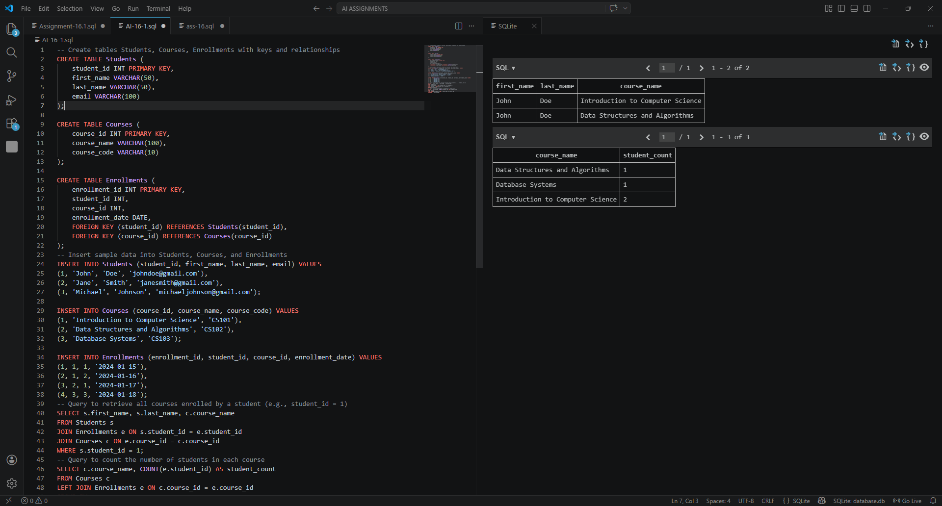
OBSERVATION:

TASK-2:
PROMPT:
CODE:
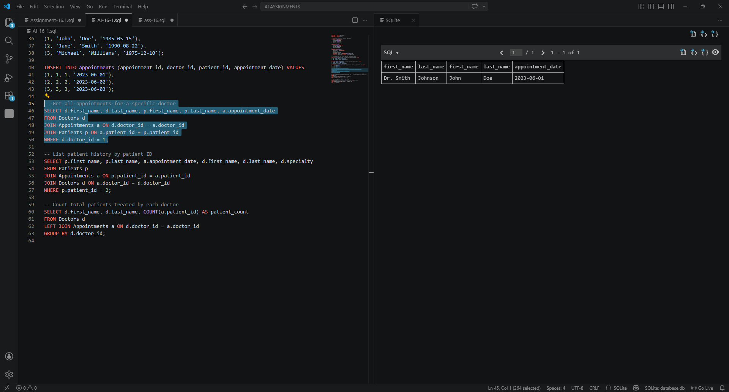
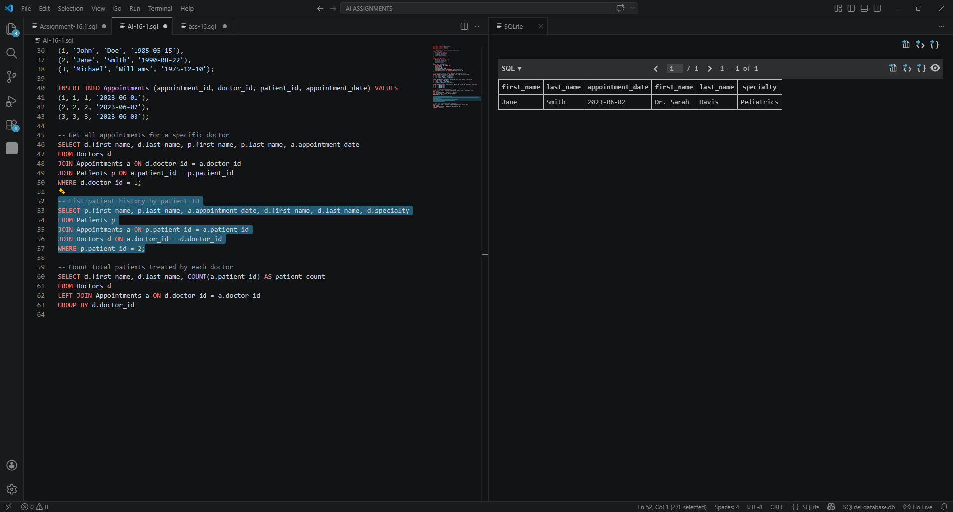
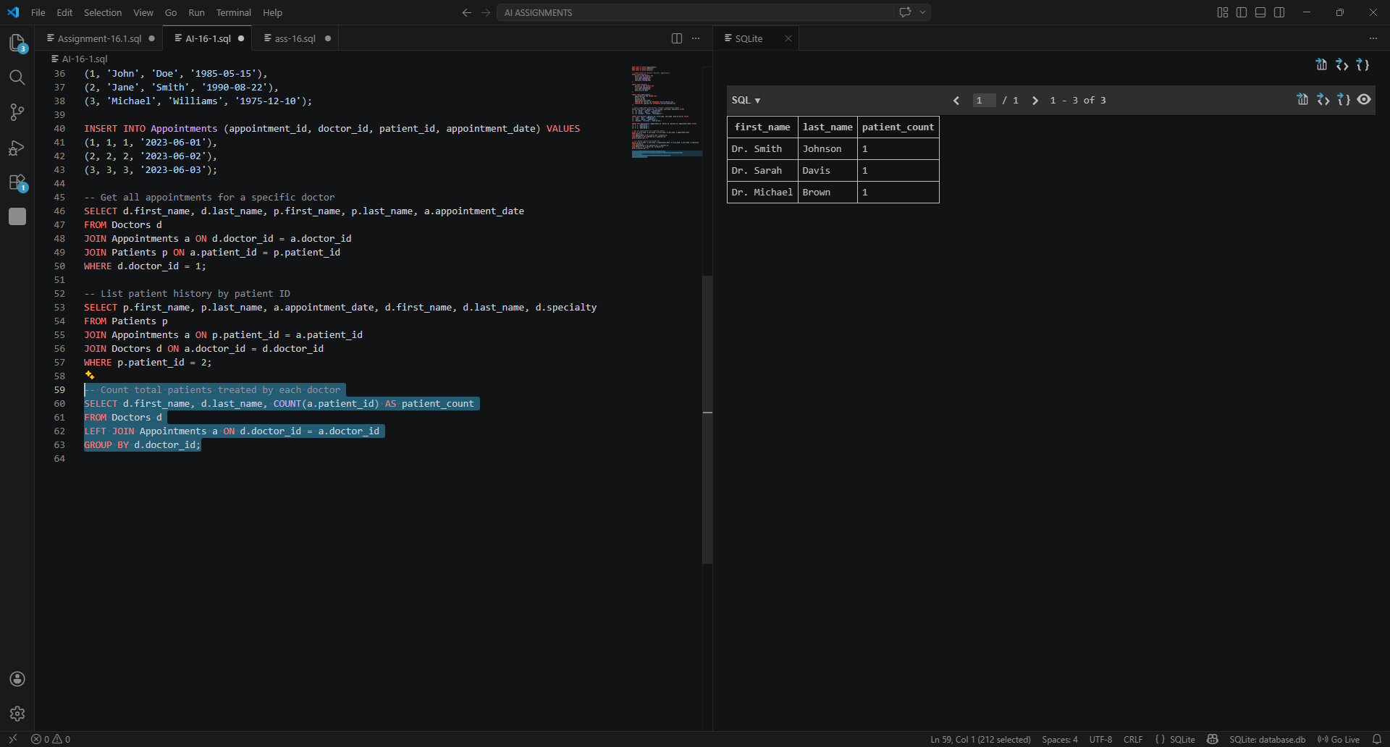
OBSERVATION:

TASK-3:
PROMPT:
CODE:
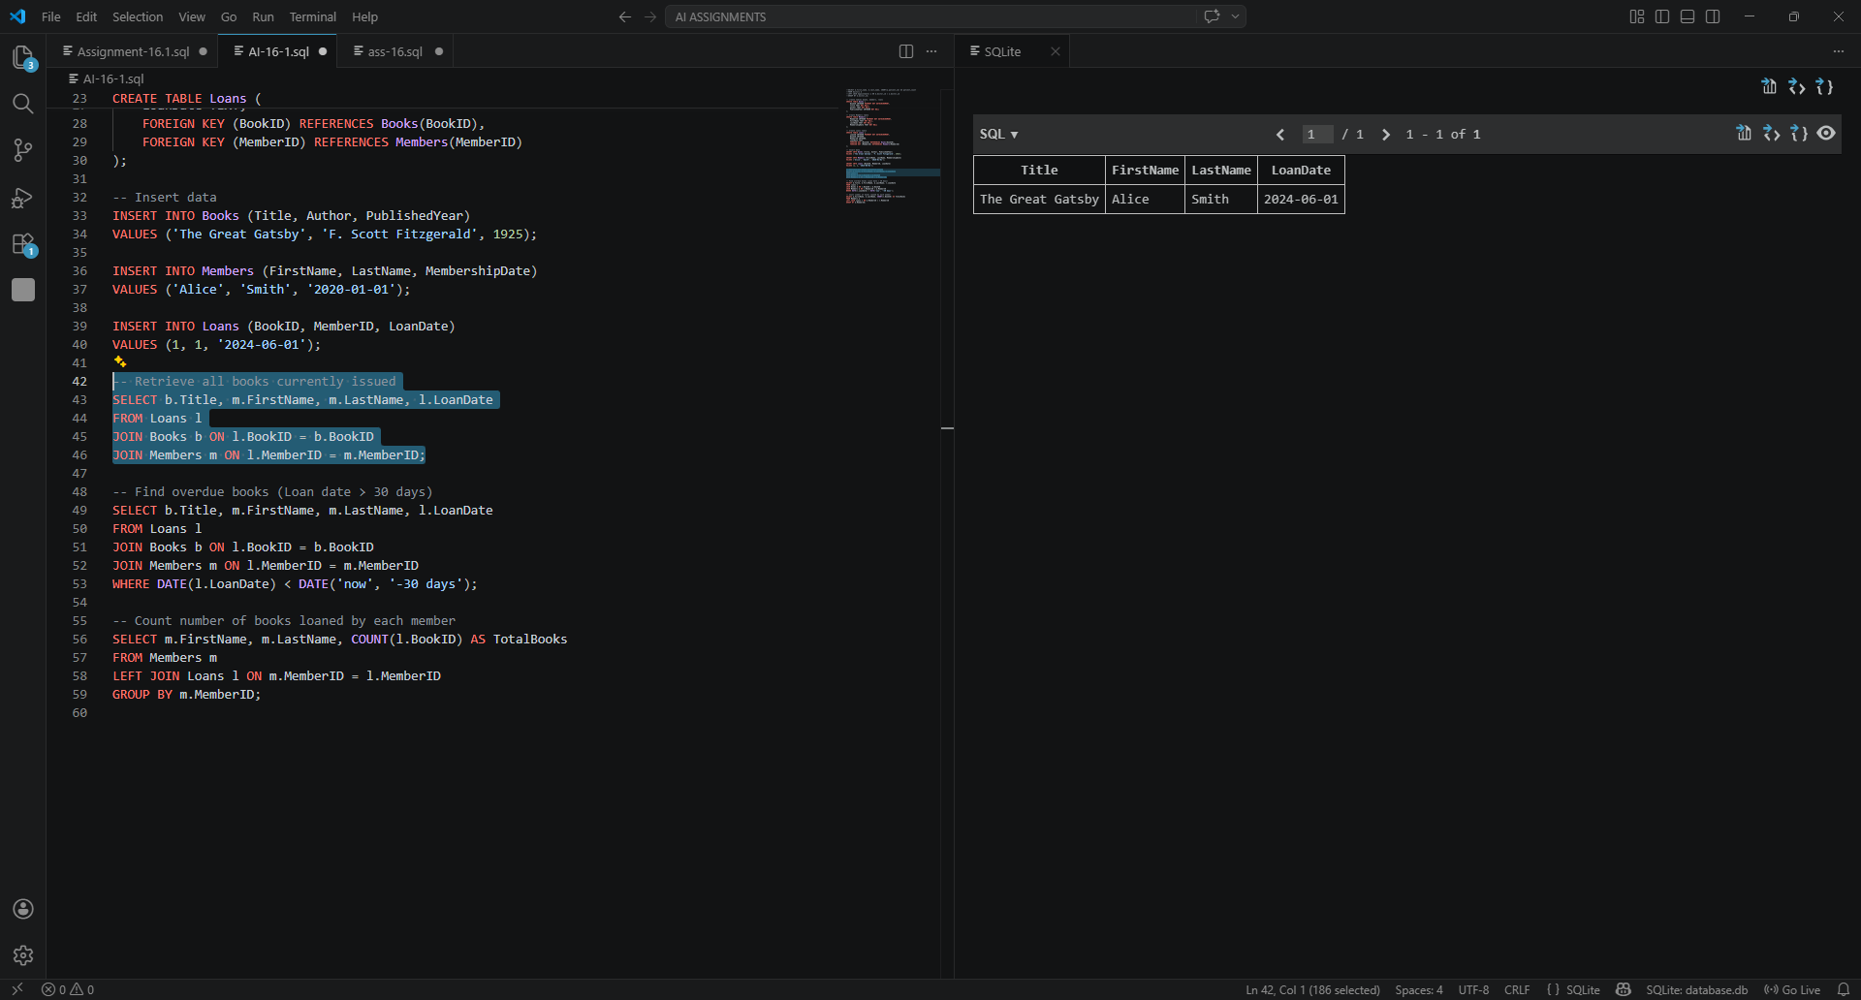
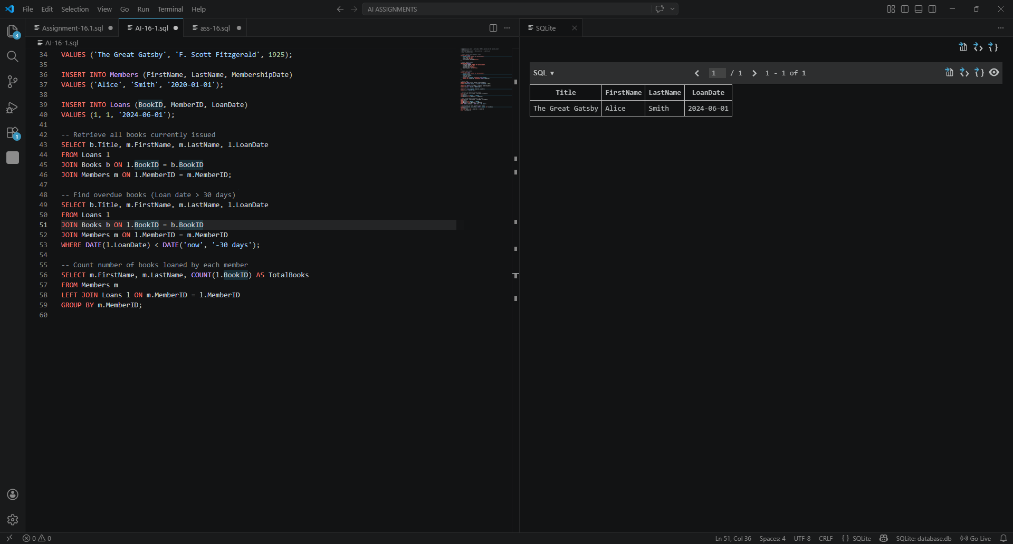
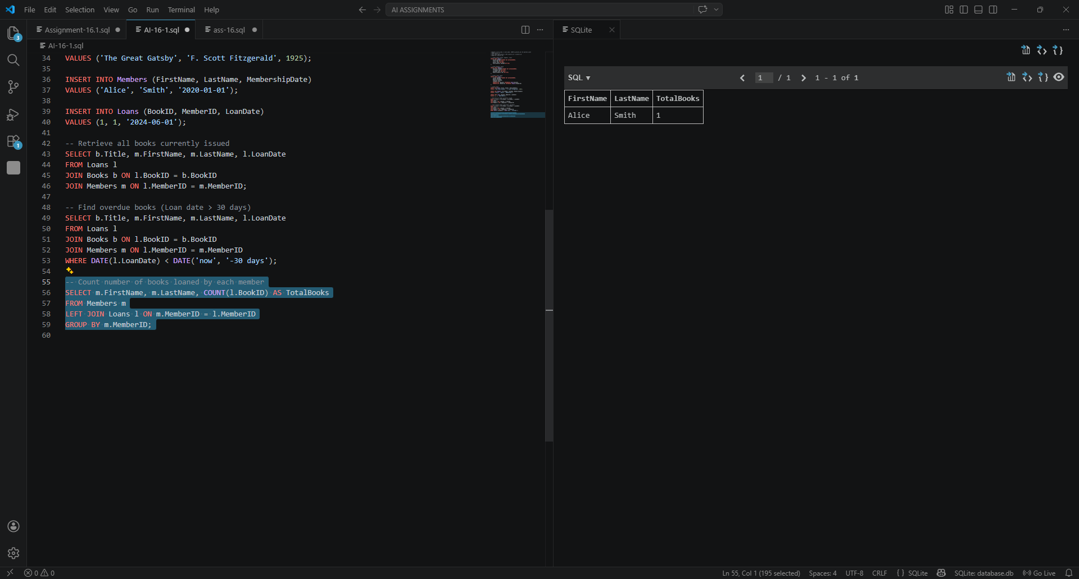
OBSERVATION:

TASK-4:
PROMPT:
CODE:
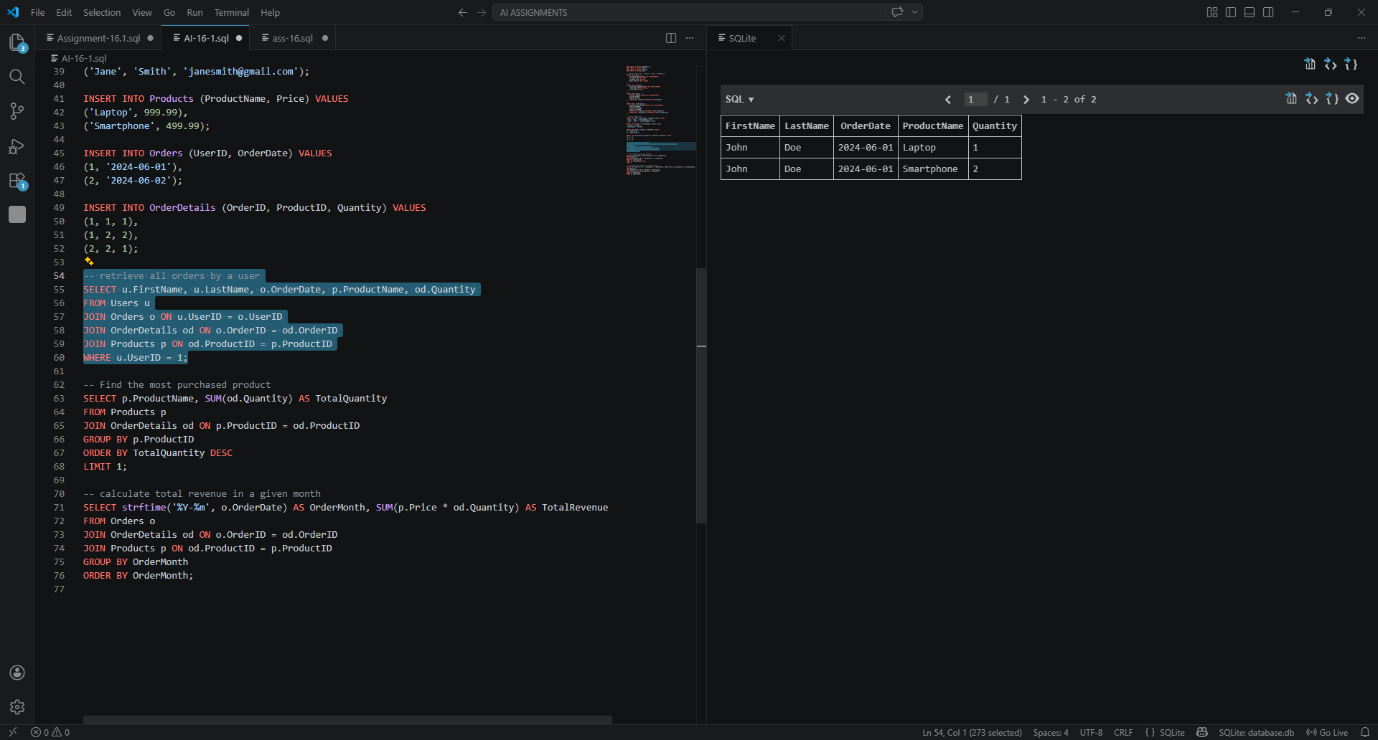
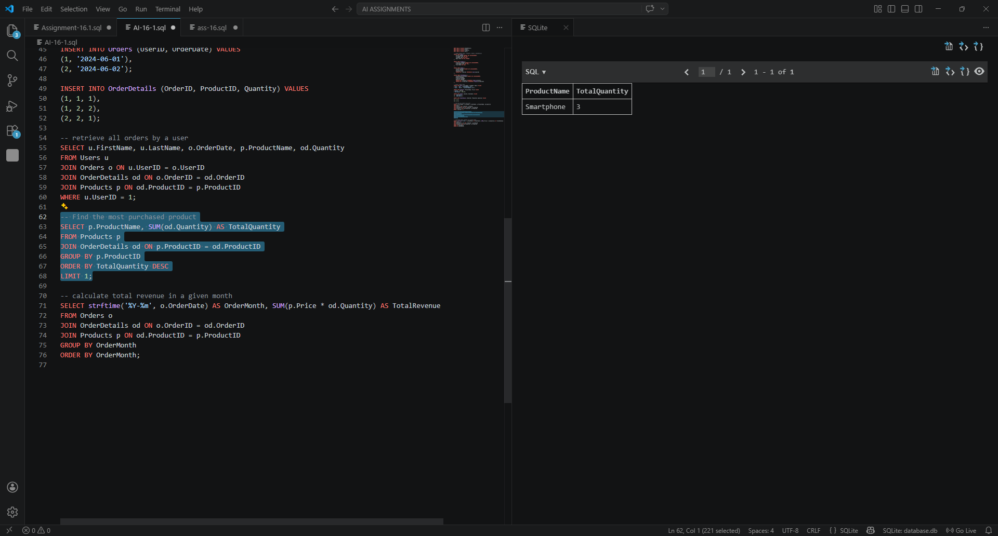
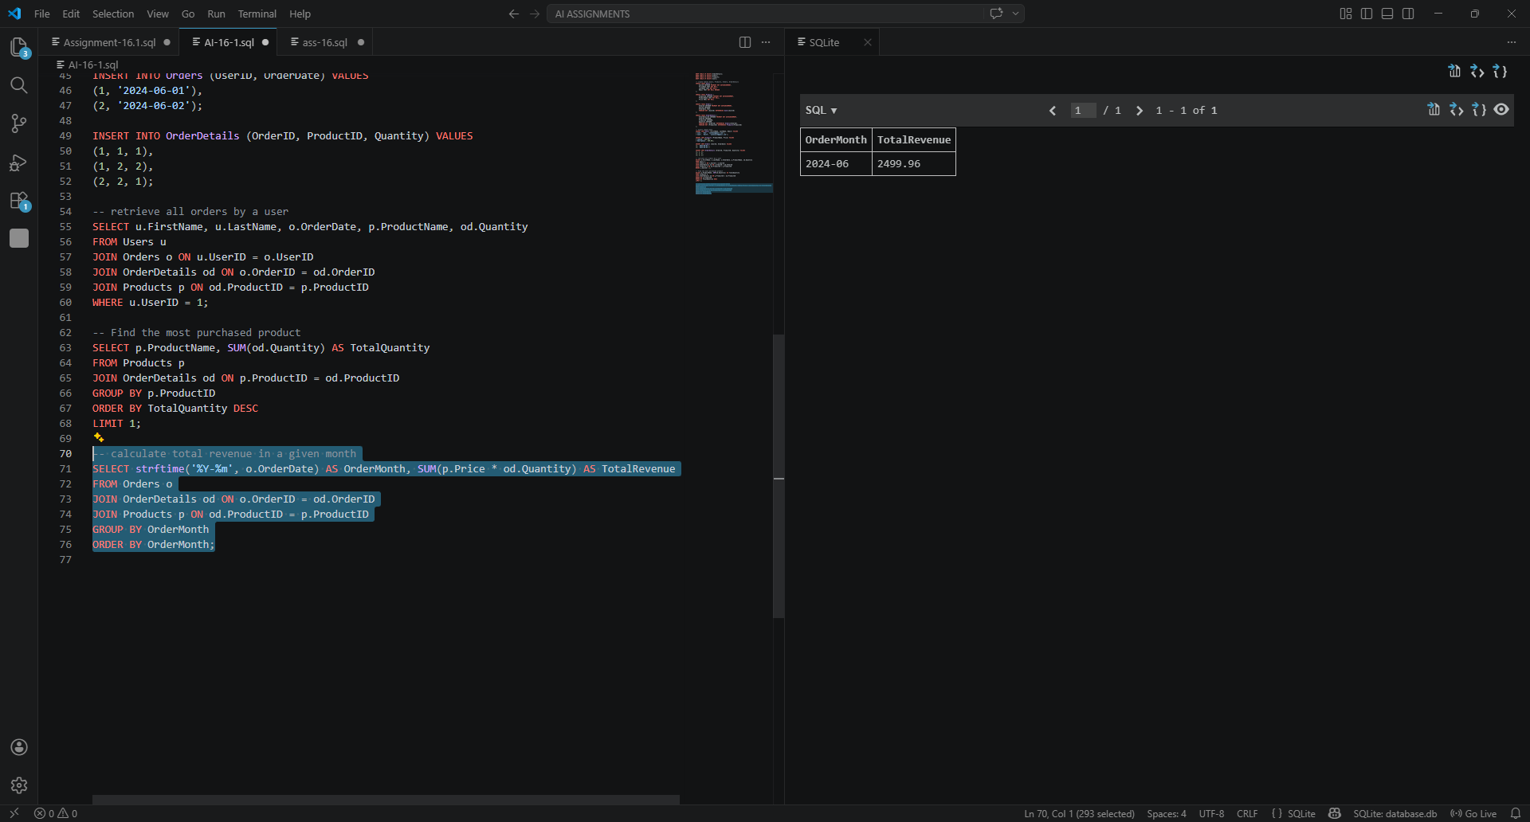

OBSERVATION:

TASK-5:
PROMPT:
CODE:
OBSERVATION:

